**Foodar 100 – Requirements (Dive Four)**

**Next step.**

Continue to get the next requirements to implement.

**Customer Stories**

|  |  |
| --- | --- |
| Story | Home Page  Update index.html to randomly select recipe from list |
| Rationale | A different recipe should show when different users navigate to the website. |

*- Continue onto next page -*

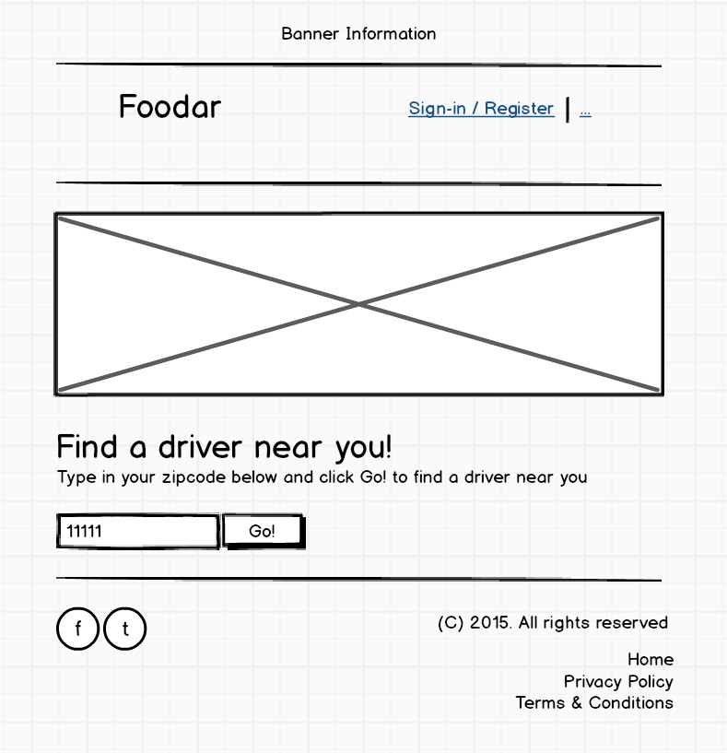

*wireframe*: index.html

*- Continue onto next page -*

**The following requirements are WHAT YOU NEED TO IMPLEMENT**

Use the below tables to understand what you will need to add to the project code

|  |  |
| --- | --- |
| Requirement | Home Page – contains() JavaScript function   1. create function to return true/false if a String is part of another |
| Number | 9 |
| Rationale | This function will be called in a different part of the program |

|  |  |
| --- | --- |
| Requirement | Home Page – zipcode search function   1. create a function that returns true/false if a zipcode is in a list |
| Number | 10 |
| Rationale | This function will be used in another Dive |

**Done.**

Now that you know a little about the system and a couple features you need to implement continue onto the next task.